

თბილისის თავისუფალი უნივერსიტეტი

კომპიუტერული მეცნიერებების, მათემატიკისა და ინჟინერიის სკოლა (MACS[E])

ელექტრო და კომპიუტერული ინჟინერიის პროგრამა

ალექსანდრე სულაბერიძე

ჯუნიორ პროექტი

ავტომატური დამიზნების სისტემა

ხელმძღვანელი: სულაბერიძე ზვიადი

თბილისი

2024

# 2. ანოტაცია/Annotation

The main idea of this project was to create a target tracking system, which based on the data received from a video camera, would detect a target object and using a mechanical "Pan-Tilt" device, with a mounted end effector (a laser), would aim at the detected object in real-time. The system should ensure that the object remains in the target.

The relevance of the topic stems from the growing demand for automation in society. The presented system is flexible, and with the selection of the right end effector, it is possible to use it for various purposes.

**Possible applications of the system:**

* **Tracking video camera system for security purposes:** The system can be used to respond to suspicious or dangerous activities. The camera detects the target, while the Pan-Tilt device ensures tracking and focusing on it. It is also possible to zoom in on the image to see details. This system is useful for both public safety and protection of private property and buildings.
* **Automated defense system:** With the selection of special end effectors, the system can detect and respond to various threats. For example, it can be used to target the source of danger, issue warnings, neutralize it, and more. Such a system could be useful for protecting private property as well as other strategic facilities.
* **Precision surgery and medical applications:** Due to the fact that even the slightest mistakes in the medical field can be fatal, there is an increasing demand for systems that can perform certain tasks flawlessly without human intervention. With the right end effector selection, such a system could be implemented here as well.
* **Industrial applications:** The system is useful for automating manufacturing and various processes. For example, it can identify objects, perform targeted processing or additional operations as they move along a conveyor belt. It is also possible to detect and eliminate undesirable activities (e.g., by selecting a robotic arm as the end effector to perform these tasks).

The modularity of the system and the ability to use different end effectors make it quite flexible and provide a wide range of applications in security, defense, medical, and industrial fields.

My main goal was to create a working prototype of this system, which could recognize simple objects, people, and others, and target them.

The result of approximately 6 months of work is the pilot version of the system, which using machine learning algorithms can provide coordinates to a microcontroller-controlled system, which then directs the end effector accordingly.

The next step, of course, is to extend the project to the aforementioned areas and adapt it to specific problems that arise in them.

ამ პროექტის მთავარი იდეა იყო სამიზნე მიმდევარი სისტემის შექმნა, რომელიც ვიდეოკამერიდან მიღებული მონაცემების საფუძველზე გამოავლენდა სამიზნე ობიექტს და მექანიკური "Pan-Tilt" მოწყობილობის გამოყენებით, მასზე დამონტაჟებული საბოლოო სამუშაო ორგანოს (End Effector) - ლაზერის საშუალებით, რეალურ დროში დაუმიზნებდა აღმოჩენილ ობიექტს. სისტემამ უნდა უზრუნველყოს ობიექტის სამიზნეში დარჩენა.

თემის აქტუალობა გამომდინარეობს საზოგადოებაში ავტომატიზაციის მზარდი მოთხოვნიდან. წარმოდგენილი სისტემა მოქნილია და სწორი საბოლოო სამუშაო ორგანოს (End Effector) შერჩევით, შესაძლებელია მისი გამოყენება სხვადასხვა დანიშნულებით.

**სისტემის შესაძლო გამოყენების სფეროებია:**

* **მიმდევარი ვიდეოკამერის სისტემა უსაფრთხოების მიზნებისთვის:** სისტემა შეიძლება გამოვიყენოთ საეჭვო ან საშიშ აქტივობაზე რეაგირებისთვის. კამერა აღმოაჩენს სამიზნეს, ხოლო Pan-Tilt მოწყობილობა უზრუნველყოფს მის კვალდაკვალ გაყოლას და ფოკუსირებას. აგრეთვე, შესაძლებელია გამოსახულების გადიდება დეტალების დასანახად. ეს სისტემა გამოსადეგია როგორც საზოგადოებრივი უსაფრთხოების, ასევე კერძო საკუთრებისა და შენობების დაცვის მიზნებისთვის.
* **ავტომატიზებული თავდაცვის სისტემა:** სპეციალური საბოლოო სამუშაო ორგანოების შერჩევით, სისტემას შეუძლია გამოავლინოს და რეაგირება მოახდინოს სხვადასხვა საფრთხეზე. მაგალითად, შეიძლება გამოვიყენოთ საფრთხის წყაროს მიზანში ამოღებისთვის, გაფრთხილებისთვის, განეიტრალებისთვის და სხვა. Მსგავსი სისტემა შეიძლება გამოსადეგი იყოს როგორც კერძო საკუთრების, ისე სხვა სტრატეგიული ობიექტების დაცვაში.
* **პრეციზიული ქირურგია და სამედიცინო გამოყენებები:** იმის გამო რომ სამედიცინო სფეროში უმცირესი შეცდომების დაშვებაც კი შეიძლება ფატალური იყოს, გაზრდილია მოთხოვნა სისტემებზე, რომლებსაც ადამიანების ჩარევის გარეშე, უშეცდომოდ შეუძლიათ გარკვეული დავალებების შესრულება. სწორი End Effector-ის არჩევით, აქაც შესაძლოა მსგავსი სისტემის დანერგვა.
* **სამრეწველო გამოყენებები:** სისტემა გამოსადეგია წარმოებისა და სხვადასხვა პროცესების ავტომატიზაციისთვის. მაგალითად, მას შეუძლია ობიექტების იდენტიფიცირება, მიზნობრივი დამუშავება ან დამატებითი ოპერაციების შესრულება კონვეიერზე გადაადგილებისას. აგრეთვე, შესაძლებელია არასასურველი აქტივობის აღმოჩენა და აღმოფხვრა (მაგალითად, End Effector-ად მექანიზებული ხელის არჩევით, რომელიც ამ დავალებებს შეასრულებს)

სისტემის მოდულარულობა და სხვადასხვა სამუშაო ორგანოების გამოყენების შესაძლებლობა მას საკმაოდ მოქნილს ხდის და იძლევა ფართო გამოყენების არეალს, როგორც უსაფრთხოების, თავდაცვის და სამედიცინო, ასევე სამრეწველო სფეროებში.

Ჩემი მთავარი მიზანი იყო შემექმნა ამ სისტემის მუშა პროტოტიპი, რომელიც მარტივი ობიექტების, ადამიანების და სხვის ამოცნობას და მიზანში ამოღებას შეძლებდა.

დაახლოებით 6 თვიანი შრომისგან მიღებული შედეგი არის ზემოხსენებული სისტემის საპილოტე ვერსია, რომელსაც მანქანური სწავლების ალგორითმების გამოყენებით შეუძლია მიკროკონტროლერით მართულ სისტემას კოორდინატები გადასცეს, რომელიც შემდეგ End Effector-ს შესაბამისად მიმართავს.

შემდეგი ნაბიჯი, ცხადია, რომ არის პროექტის ზემოხსენებულ სფეროებში განვრცობა და მათში გაჩენილი კონკრეტული პრობლემებისთვის მორგებაა.

# 3. Table of Contents:

2. ანოტაცია/Annotation 1

3. Table of Contents: 5

4. List of Formulas, Graphs, and Pictures 6

5. Introduction 7

6. The Problem Statement & The Proposed Solution 8

6.1. Research Conducted Related to the Project Topic 8

6.2. The Technical Side of the Project 10

6.2.1. Mechanical Part 10

6.2.2. Electronics & Control 12

6.2.2.1 Rotary Encoders & Angle Feedback 13

6.2.2.2 Motor Control 14

6.2.2.3 PID Control 15

6.2.2.4 Main Loop 18

6.2.2.5 USART Communication 18

6.2.2.6 Camera Installation 19

6.2.3. Software 19

6.2.3.1 The Main Program 20

6.2.3.2 Machine Learning Model 20

6.3. Result & Comments 22

7. Conclusion 23

8. List of References & Resources Used 25

9. მადლობის გვერდი 26

Appendix 28

# 4. List of Formulas, Graphs, and Pictures

**#1 -** Initial Block Diagram (The end results moderately deviate from this block diagram)  
**#2 –** Gear Nomenclature  
**#3 –** Design Process  
**#4 –** STM32F103 Generic BluePill Board Pinout.  
**#5 –** STM32 Encoder Mode Principle  
**#6 -** STM32 PWM Formulas  
**#7 -** PID Controller Gains Tuning Effects.  
**#8 –** PID Controller Block Diagram  
**#9 –** PID Controller Difference Equation after Bilinear Transform  
**#10 –** Spirally wrapped cables for signal integrity  
**#11 –** Screenshot: Machine learning model detecting tennis ball  
**#12 –** Final look

# 5. Introduction

As I hadn't done any visually appealing projects during my time at university, I wanted to work on a project that would soothe the Sci-Fi starved mind of the person that grew up reading authors like Isaac Asimov. The project would have to have moving parts that fit together in an elegant way to look impressive to the outside observer, even one with no engineering knowledge.

The project I chose to work on was the development of a target tracking system that could detect and aim at a target object using a video camera, a mechanical "Pan-Tilt" device, and a mounted end effector (e.g., a laser). The system would be capable of tracking and maintaining the target in its sights in real-time, showcasing the coordination of various components in a visually appealing manner.

While the relevance and potential applications of this project have been discussed in detail in the annotation, it is worth mentioning that such a system could have diverse uses in fields like security, defense, medical, and industrial automation, among others, depending on the choice of the end effector and specific requirements.

**Note:**   
Sentences written using ~~strikethrough~~ represent previous versions of the project that I choose to keep within the report.

# 6. The Problem Statement & The Proposed Solution

## 6.1. Research Conducted Related to the Project Topic

**Existing Technologies and Market in the Field:**

In recent years, there has been a growing interest in developing systems that can autonomously track and maintain focus on a target object. Such systems have found applications in various domains, including security surveillance, defense tracking, industrial automation, and medical procedures. The market for target tracking systems is projected to grow significantly, driven by the increasing demand for autonomous solutions and the integration of advanced technologies like computer vision and robotics.

**Challenges in the Field:**

One of the major challenges in developing robust target tracking systems is handling complex scenarios where the target may move erratically, become occluded, or undergo changes in appearance. Traditional approaches based on simple feature tracking or template matching often fail in these situations. Additionally, integrating real-time tracking with precise mechanical positioning and control mechanisms poses significant technical challenges.

**Future Development Perspectives in the Field:**

The field of target tracking is rapidly evolving, with continuous advancements in computer vision algorithms, machine learning techniques, and robust control systems. The integration of deep learning models for object detection and tracking is expected to greatly enhance the performance and adaptability of these systems. Furthermore, the development of low-cost and highly accurate positioning mechanisms, such as Pan-Tilt devices, will enable the deployment of target tracking solutions in a wider range of applications.

**Problem Statement and Novelty:**

This project aims to develop an innovative target tracking system that can detect and maintain focus on a target object in real-time, using a combination of computer vision techniques and a mechanical Pan-Tilt mechanism with a mounted end effector (e.g., a laser). The system will be capable of handling challenging scenarios, such as occlusions and erratic movements, by leveraging advanced object detection and tracking algorithms. The integration of the computer vision component with the precise positioning mechanism represents a novel approach to creating a visually appealing and practical target tracking solution.

**Technical Objectives and Requirements:**

* Develop a computer vision pipeline for robust object detection and tracking, capable of handling occlusions and appearance changes.
* Implement algorithms for accurate and smooth control of the Pan-Tilt mechanism, ensuring precise target positioning.
* Design and integrate a suitable end effector (e.g., laser pointer) to be mounted on the Pan-Tilt device.
* Create a user-friendly interface for target selection and system control.

**Relevance and Potential Applications:**

The developed target tracking system has the potential for applications in various domains, such as security surveillance, defense tracking, industrial automation (e.g., robotic assembly lines), and medical procedures (e.g., surgical assistance). By demonstrating the seamless integration of computer vision and mechanical positioning, this project can pave the way for the development of more advanced and versatile target tracking solutions.

**Commercialization Potential:**

The target tracking system developed in this project could have significant commercial potential, particularly in industries where precise and autonomous tracking is required. With further refinement and customization for specific use cases, the system could be marketed as a standalone product or integrated into existing solutions offered by companies operating in the relevant domains.

## 6.2. The Technical Side of the Project

As depicted in the initial block diagram modelled before the project itself began, the discussion of the technical side of the project will be split into 3 main and numerous sub-parts.

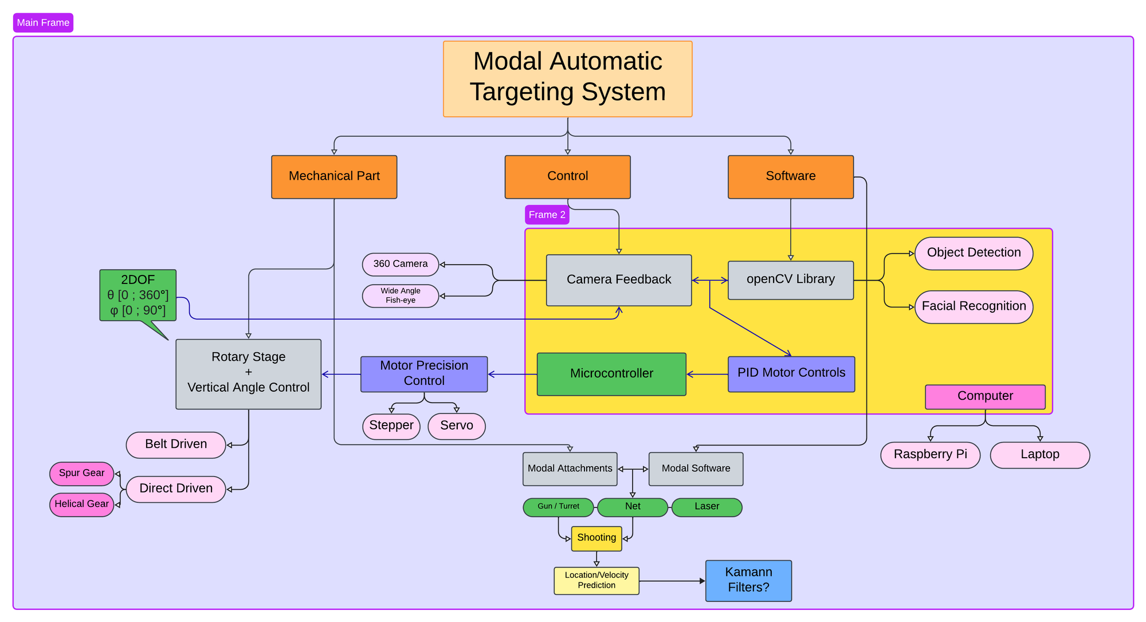

*Picture #1 – Initial Block Diagram*

### 6.2.1. Mechanical Part

The overall structure comprises three main components: a wooden base housing the electronics, a pan mechanism, and a tilt mechanism. Each of the pan and tilt mechanisms incorporates a DC motor, a rotary encoder, a slip ring, and three 3D-printed helical gears for mechanical power transmission.

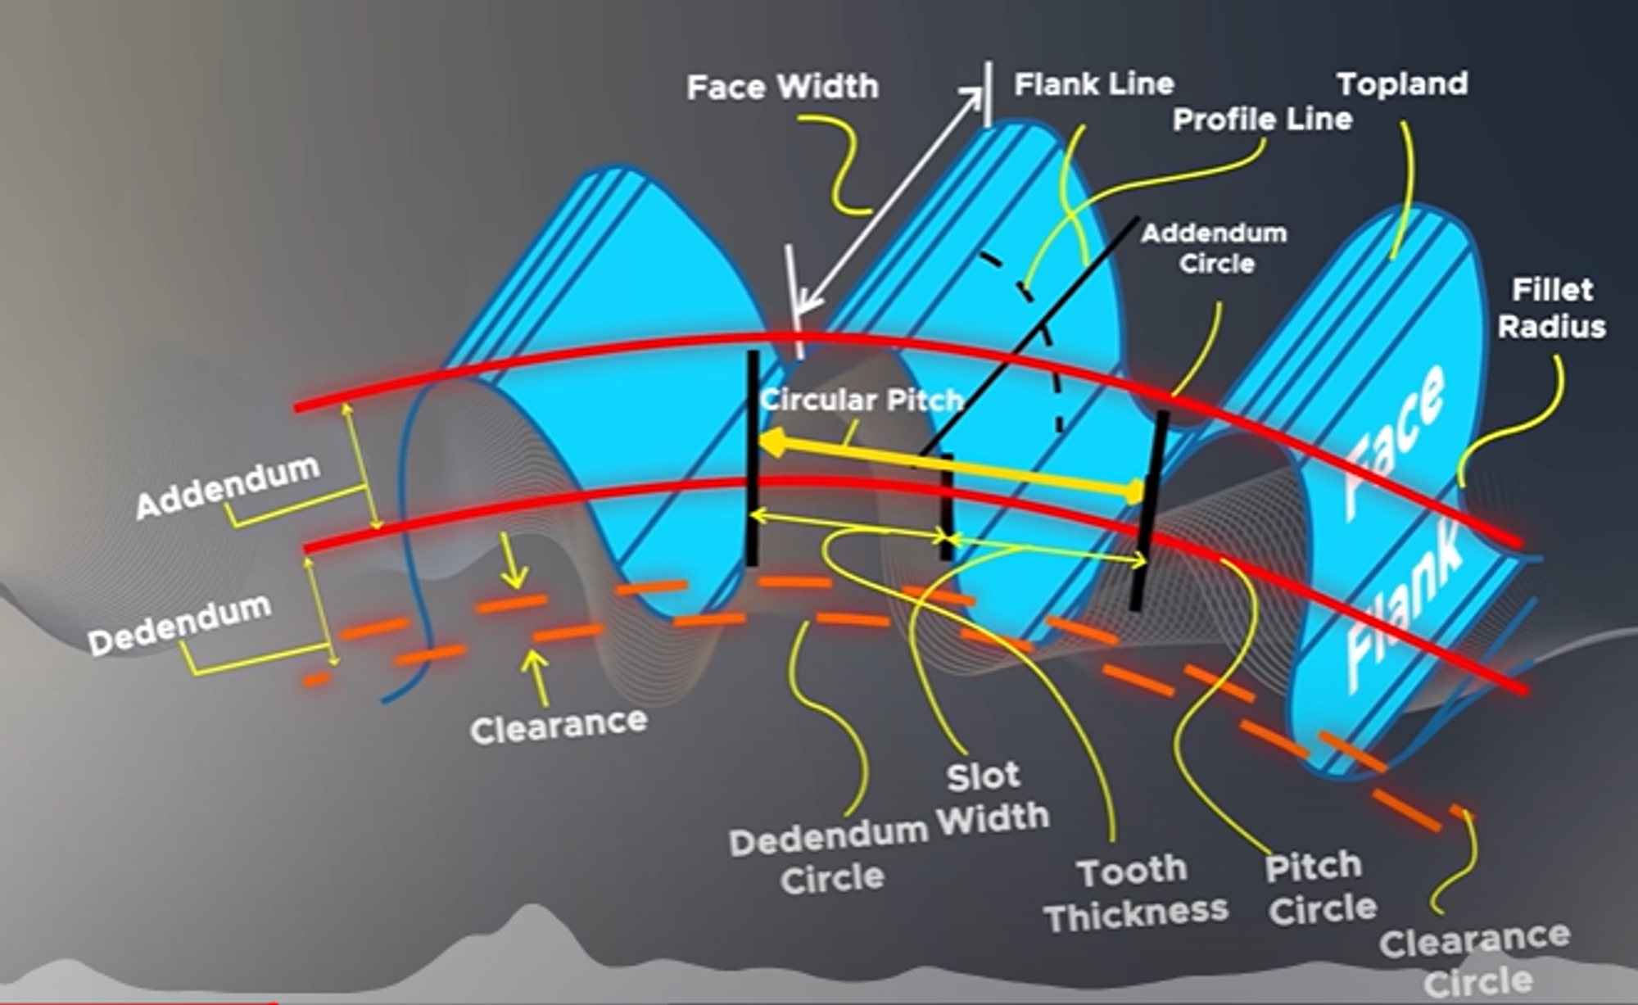  
*Picture #2 – Gear Nomenclature*

* **The Wooden Base:** A box constructed from plywood with CNC-milled slots for the pan mechanism.
* **The Pan Mechanism:** The main platform is driven by a 2mm module 140-tooth helical gear, rotated by a 27-tooth helical gear. Adjacent to the main gear, a rotary encoder is coupled with another 27-tooth helical gear. The slip ring is fed through the center of the main platform, allowing the electronics to pass through the box without tangling.  
  + The rotary encoder has 200 pulses per rotation, but the STM32's encoder mode enables counting 800 pulses per rotation. With this gear ratio, each rotation of the main platform corresponds to approximately 4148 pulses (800 × 140/27), providing a precision of about 0.087 degrees.
* **The Tilt Mechanism:** Mounted onto the pan mechanism's main platform, the tilting platform is driven by a 1mm module 50-tooth double helical gear, rotated by a 25-tooth double helical gear. Adjacent to the main gear, the same rotary encoder is coupled with another 50-tooth double helical gear. The slip ring is fed through the side parallel to the gear.  
  + As this uses the same rotary encoder with a 1:1 gear ratio, each rotation of the tilting platform corresponds to 800 pulses, providing a precision of 0.45 degrees.

The gear design was created using DS SolidWorks, which played a crucial role in the initial design process and visualization. Significant time was dedicated to learning and refining design skills, iterating through various concepts for the project's appearance.

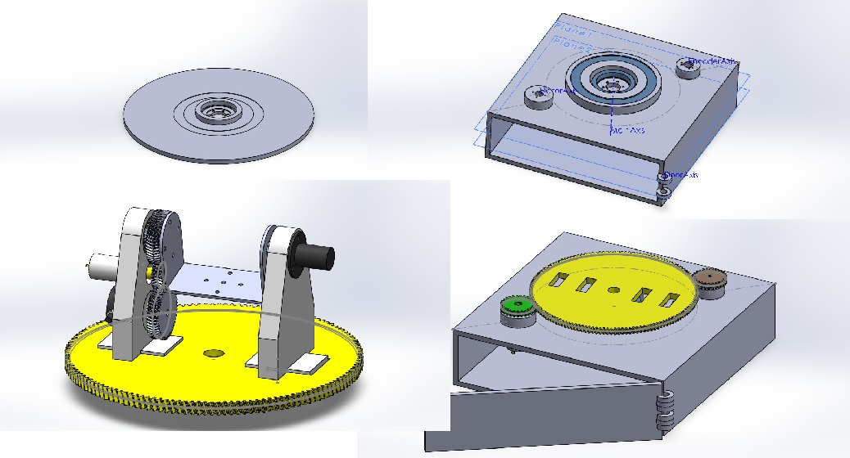  
*Picture #3 – Design Process*

**Note:** The pan mechanism's gear ratio is not an exact 5:1 (140/28) due to the failure to account for 3D printing tolerances when manufacturing the gears. A 28-tooth version fit too tightly, posing a risk of jamming the system. In practice, this small discrepancy did not pose a significant problem.

**Note:** All moving parts are mounted with suitable ball bearings and thrust bearings to minimize friction as much as possible.

### 6.2.2. Electronics & Control

The main controller is an STM32F103 Bluepill board handling motor control, communication, and sensor inputs. The power source is a 12V supply connected to a 220V AC outlet. A step-down converter provides 5V to the Bluepill's 5V pin, and the on-board regulator supplies 3.3V to the MCU. Each of the pan and tilt mechanisms have a 12Volt 300rpm internal gearbox DC motor driven by a dual-channel motor driver, and a 200-pulse rotary encoder. The wooden enclosure has a power button with an LED ring indicating power status, and two USB Type-B Female connectors: one for connecting the tilt-mounted camera to a computer for running the CV algorithm, and another for establishing a USART connection between the computer and the STM32 to send and receive information (e.g., new setpoint data).

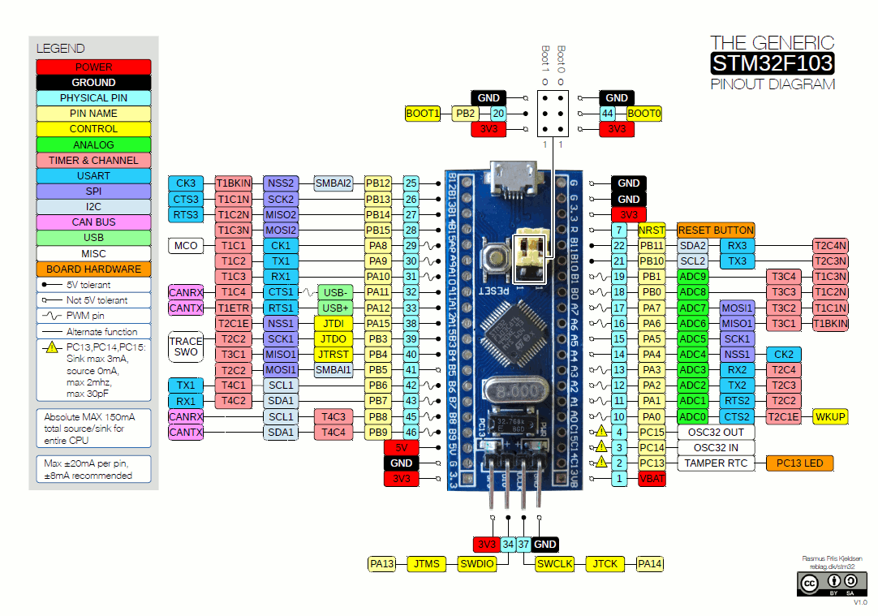  
*Picture #4 – STM32F103 Generic BluePill Board Pinout.*

#### 6.2.2.1 Rotary Encoders & Angle Feedback

**Note:**   
Not used in the final version of the project, although still works and could prove useful in future reiterations.

The rotary encoders are connected directly to the STM32 Bluepill board. The STM32F103 has a High-Speed Timer (HRTIM) and three General Purpose Timers (GPTIMs), each with 4 channels. Two GPTIMs are configured in encoder mode, reserving two GPIO pins, one for each channel the encoder mode requires. The A and B terminals of the encoders are connected to these pins. In encoder mode, each pin, upon receiving a rising or falling pulse (configured for both), triggers an interrupt that updates the CNT Register of the timer based on which GPIO pin last fired the interrupt, accounting for the spinning direction of the encoder shaft. With this configuration counting both falling and rising pulses of both A and B terminals of the encoder, the 200-pulse encoder effectively becomes an 800-pulse encoder. Due to the 1:1 gear ratio, the tilt mechanism's TIMx auto-reload value is set to 800, while the pan mechanism, with a 27:140 ratio, has its TIMx auto-reload value set to 4148. These counter values, extracted from the TIMx->CNT Registers, can be used to determine the angular position of the mechanism.

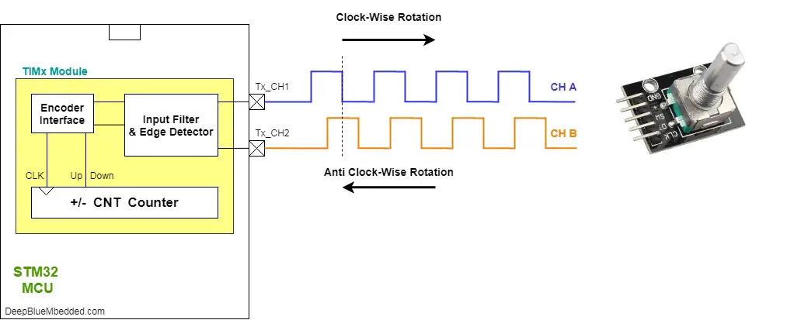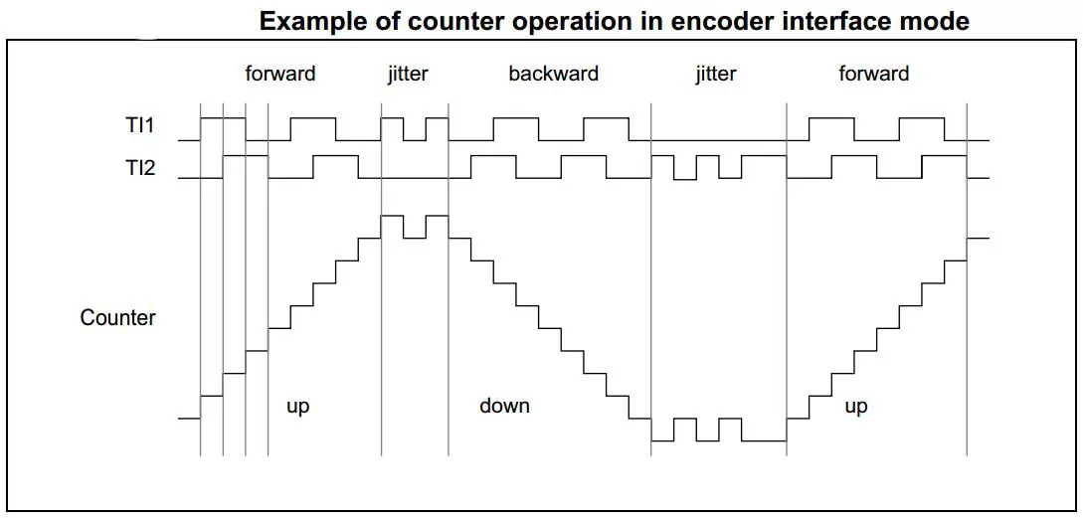  
*Picture #5 – STM32 Encoder Mode Principle*

For more details on the Encoder Mode:

<https://deepbluembedded.com/stm32-timer-encoder-mode-stm32-rotary-encoder-interfacing/>

#### 6.2.2.2 Motor Control

The 12V DC Motors are driven by a DFRobot dual-channel motor driver powered by a 12V power supply. Each channel has three control signals: logical A and B signals for direction control, and a PWM signal for speed control based on the duty cycle. The control signals come from GPIO pins, and each channel has its own 3.3V power line from the MCU. Two channels of the General Purpose Timer are used for PWM signals. The MCU runs at 72MHz, and the PWM Resolution is set to 16 bits, giving a PWM Frequency of approximately 1.1KHz (72Mhz/65535). The duty cycles of the PWM signals are set using the TIMx->CCRx Registers. A PID Controller is implemented on the STM32 to control the motors for specific tasks.

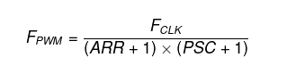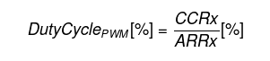

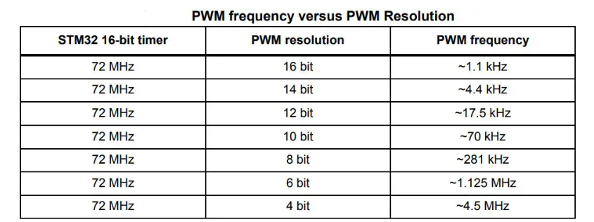  
*Picture #6 - STM32 PWM Formulas*

For more details on PWM Control:

<https://deepbluembedded.com/stm32-pwm-example-timer-pwm-mode-tutorial/>

#### 6.2.2.3 PID Control

The PID Controller for the system went through three iterations. Before discussing them, let's first discuss the main outline of the controller.

~~The setpoint is the target angle provided by the CV Algorithm on the computer. The feedback term is the current angular position from the encoder. Due to the wrap-around nature of the coordinates, the error term is calculated as the minimum of the clockwise and counterclockwise distances from the current position to the setpoint, allowing the direction to be set outside the PID Controller. The error term in pulses is scaled to a range of 0 to 180 degrees.~~

The setpoint is the center pixel of the frame provided by the mounted camera, while the projected point is the center pixel of the largest bounding box provided by the result of the machine learning model, which is to be discussed in a later section.

The output is scaled to a number from –0.98 to 0.98 (I chose to keep small overhead between the maximum and minimum inputs the controller can take and the maximum and minimum outputs the PID controllers can provide), with the sign representing direction, and the value representing the percentage of the motor's maximum speed, then multiplied by 65535 (the maximum duty cycle for a 16-bit PWM signal) and written to the relevant CCRx register to set the motor speed. This process constitutes one PID cycle.

The PID controller is written in C directly for the STM32, implemented as a separate .h and .c file as a struct with its own methods/functions. This allows creating multiple PID controllers with different gain coefficients and output saturation limits. The controller used in the project was tuned using trial and error, tweaking the gains in response to the system's observed behavior, such as overshoot or insufficient response time.

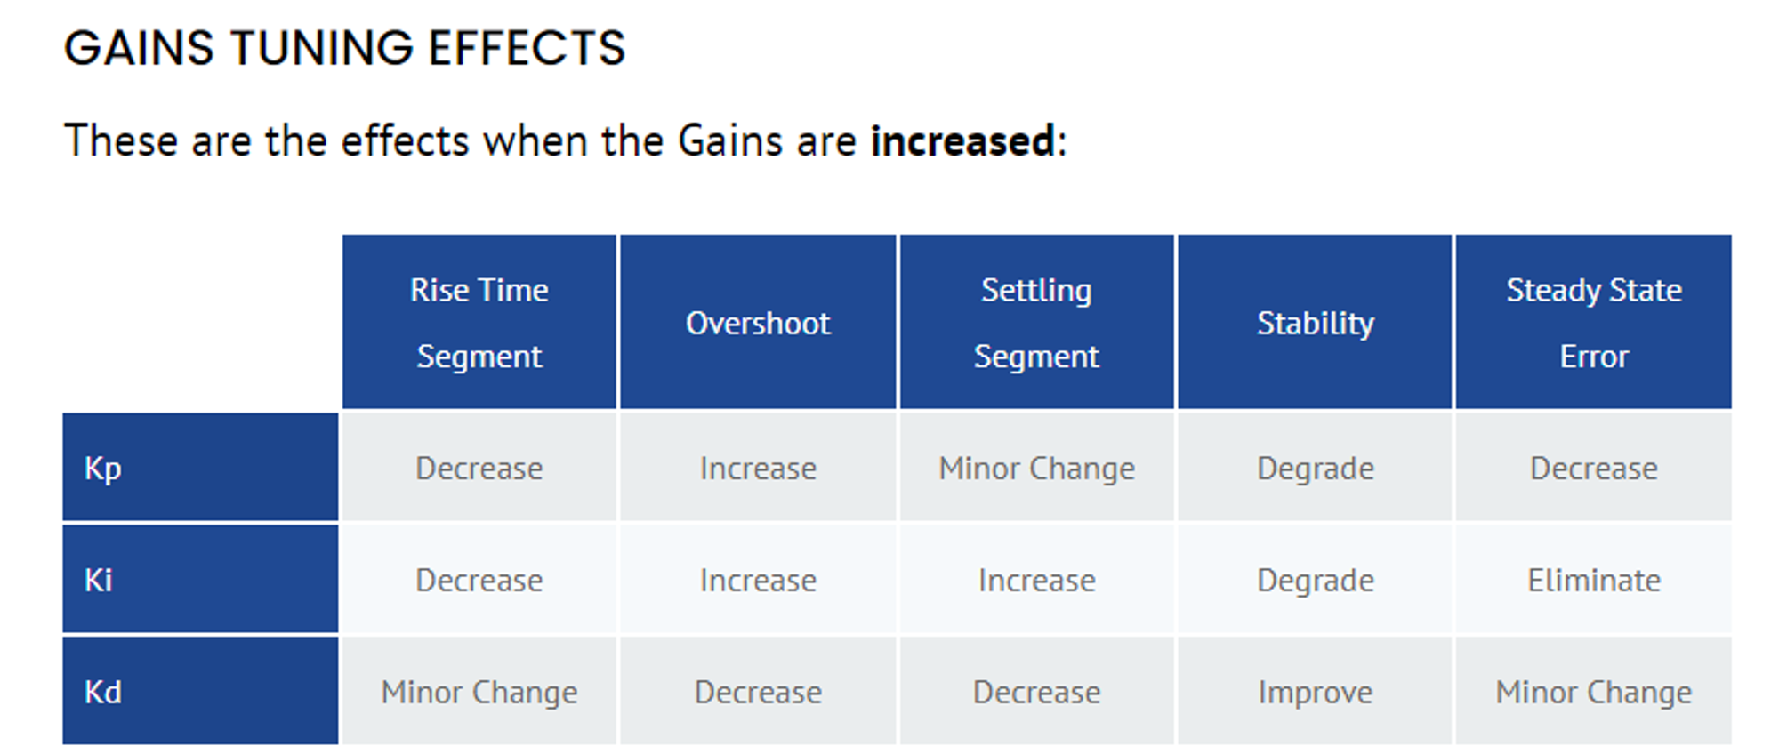  
*Picture #7 - PID Controller Gains Tuning Effects.*

The first iteration of the PID controller was written with the most basic PID arrangement, the P term proportional to the error, the I term the sum of errors scaled by the gain, the D term the difference of the current and last error.

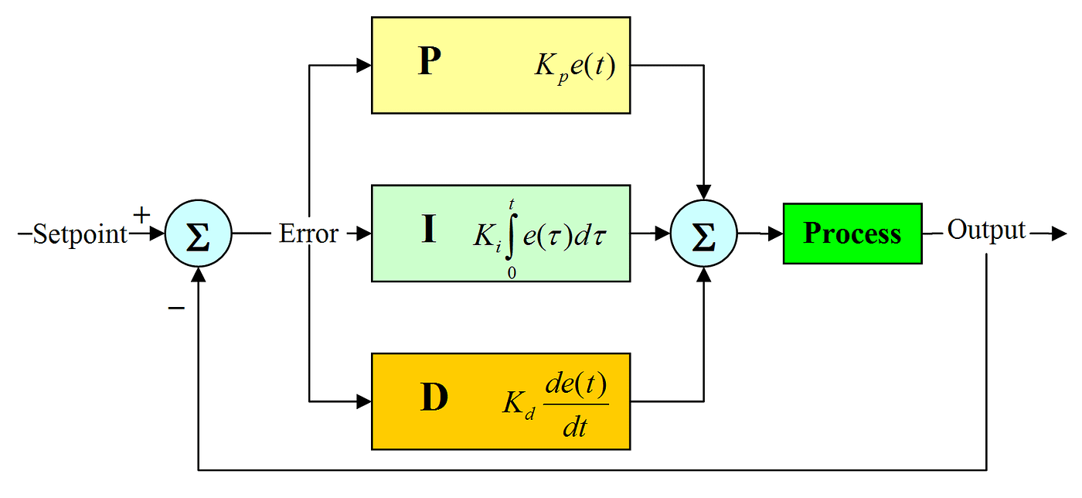  
*Picture #8 - PID Controller Block Diagram*

The second iteration of the PID controller was written based on the bilinear transform of the basic analog PID controller, implementing a low pass filter with the D term to eliminate high frequency noise gain.

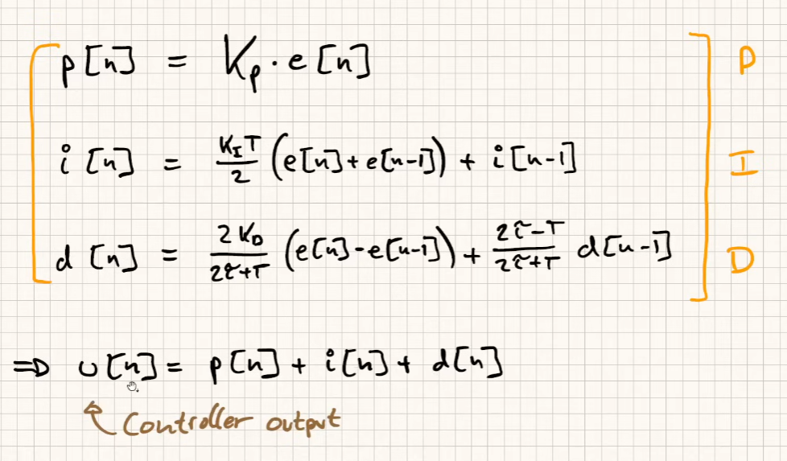  
*Picture #9 - PID Controller Difference Equation after Bilinear Transform*

There were a couple of problems with these controllers, namely:

* Integrator windup
* Derivative “Kick” during the setpoint change
* Choosing sample time

The third and final iteration of the PID controller was implemented using a library (See References) as a template. The sampling time for scaling calculations is computed each cycle as the difference between the current time and the last iteration, resulting in a dynamic sample time. The derivative "kick" issue was resolved by calculating the derivative term as the difference between the current and last measurement, rather than the error, preventing sudden jumps due to setpoint changes (Note: The sign of the D term changes due to this). To address integrator windup, the integrator term is clamped to a minimum and maximum value, which is sufficient for this application, although other methods like dynamic integrator anti-windup exist.

I decided not to use the lowpass filter that is usually included with the D term to keep the controller simple, instead, the lowpass filter is integrated into the python script that generates the input coordinates (projected points) to the system via moving average.

~~While the library simplified the implementation, it did not account for the wrap-around nature of the system. Modifications were made to the error and dInput (dInput = input - uPID->LastInput) calculations within the library to address this. The change involves taking the minimum of the counterclockwise and clockwise differences for each calculation, ensuring that there are no sudden jumps in the difference. For example, when the main platform passes 4148 pulses and wraps around to 0, the dInput should not experience a large jump.~~

#### 6.2.2.4 Main Loop

The main program starts by initializing the two PID controllers for the pan and tilt mechanisms, followed by initializing all the MCU peripherals using the generated code from the STM32CubeIDE. The main while loop consists of back-and-forth USART communication and a call to the "runMotors(&basePID, &tiltPID, base_proj_point, tilt_proj_point, base_set_point, tilt_set_point)" method, which updates the motor speed based on the given parameters and the PID Controllers passed.

The main program has two main changing variables, base_proj_point and tilt_proj_point, which remain equal to the constant setpoint (the center pixel of the camera frame) unless updated from the serial data received by the STM32 from the computer. The runMotors() method runs the PID algorithm for both motors each cycle. In steady state, when the setpoint hasn't changed, the system is expected to remain still.

#### 6.2.2.5 USART Communication

The communication between the MCU and the computer is established using the USB2TTL Unit connected to the Bluepill board. The USB2TTL chip allows sending serial data back and forth.

~~The HAL_UART_Receive_IT() function generates an interrupt each time a character is received in the input stream. To receive both coordinates at once, the USART interrupt routine was modified as follows: During each ISR, the global variables baseBuffer or tiltBuffer are updated. The 'a' character is arbitrarily selected as the sentinel character. Initially, the baseBuffer is updated until the sentinel character appears, after which the following numbers update the tiltBuffer. After the second 'a' character, the contents of both buffers are moved into baseSetPoint and tiltSetPoint, which are then fed into the runMotors() method to drive the motors.~~

The reception of data is accomplished using Direct Memory Access (DMA). This approach is superior to the previous interrupt-based approach because the HAL_UART_Receive_DMA() function receives bytes into its buffer without relying on the CPU to execute the interrupt service routine (ISR). This means that the CPU has a reduced workload, allowing it to focus on other tasks.

Each time the buffer is filled, a callback function is invoked, which parses the received bytes into numbers and updates the relevant variables in the code. The DMA is configured to use a 6-byte buffer, expecting the data in the following format: "xxxyyy", where 'xxx' represents the X coordinate of the object, and 'yyy' represents the Y coordinate.

Additionally, a simple synchronization mechanism is implemented to ensure that the data is not received out of phase (e.g., "xxyyyx"). This mechanism works by first arming the DMA with a 1-byte buffer, waiting for a start character (in this case, 'a'), and then rearming the DMA with a 6-byte buffer to receive the 6 relevant bytes. This transforms the data format into "axxxyyy", where 'a' is the starting character.

Independent from what was previously discussed, the MCU regularly sends the important bits of data to the computer.

#### 6.2.2.6 Camera Installation

The camera used in the project is a generic USB camera mounted on the tilt mechanism. The camera's cable is fed through two sets of slip rings and routed out of the enclosure using a USB A-to-USB B adapter that passes through the wall of the enclosure.

One of the challenges faced during the implementation was the degradation of signal integrity caused by the slip rings and the process of cutting and resoldering the wires. This issue prevented the laptop from recognizing the USB camera as a valid device.

To resolve this problem, the following solution was implemented: the data+ and data- wires were spirally wrapped around each other, and all solder was removed from the wires. Instead of soldering, the Western Union splice method was used to combine the wires. This approach helped restore the signal integrity sufficiently for the camera to be recognized as a USB device and function correctly.

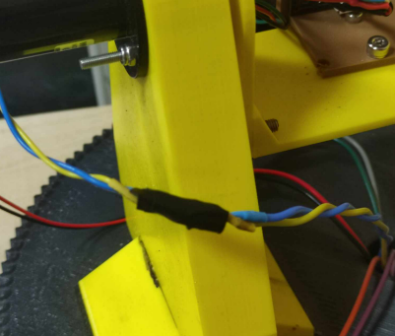  
*Picture #10 – Spirally wrapped cables for signal integrity*

### 6.2.3. Software

The software is built in the Python programming language, utilizing the OpenCV and Ultralytics libraries for handling machine learning-related tasks. The script establishes a serial connection between itself and the STM32 microcontroller and accesses the mounted camera.

#### 6.2.3.1 The Main Program

The camera captures frames and sends them in grayscale to the Python script, which processes these frames through a machine learning model trained to detect a specific object (in this case, tennis balls). The script then plots bounding boxes onto the frames, filtering out boxes with a confidence score below 0.5. Subsequently, it calculates the center coordinate of the largest remaining bounding box and transmits this data over the serial connection.

To improve the stability of the transmitted data, a moving average filter is applied to smooth the calculated coordinates before sending them to the microcontroller, although this moving average introduces a delay into the system, so window size can vary depending on the delay acceptable for the system.

#### 6.2.3.2 Machine Learning Model

The project utilizes the YOLOv8n model from Ultralytics for object detection. A pre-trained YOLOv8n model was fine-tuned using open-source datasets obtained from Roboflow. The training process was carried out on Google Cloud GPUs using Google Colab.

~~Since the camera used in the project captures grayscale images, all the training data was preprocessed into grayscale format. Additionally, the training data was carefully curated to include the target object (tennis ball) at various sizes, ensuring that the model can detect the object accurately, both at closer and farther distances.~~

The original grayscale camera was replaced with a high-resolution RGB camera capable of 30 frames per second (the frames per second slightly limit the speed of the object that can still be recognized by the model). The model was trained on a diverse dataset of color images featuring tennis balls at various sizes, enabling object detection across different distances. Running on an RTX3050 GPU with CUDA acceleration, the model's inference time was significantly reduced from 90ms (on CPU) to approximately 7ms.

A key challenge in using less powerful hardware for this task is the latency in transmitting projected point information. This delay hinders the PID controller's ability to react promptly, necessitating a compromise on system speed. Conversely, with reduced latency, the system demonstrates markedly improved accuracy and responsiveness.

The decision to use a tennis ball as the target object was made due to the abundance of labeled data available online and the ease of acquiring tennis balls for testing and demonstration purposes.

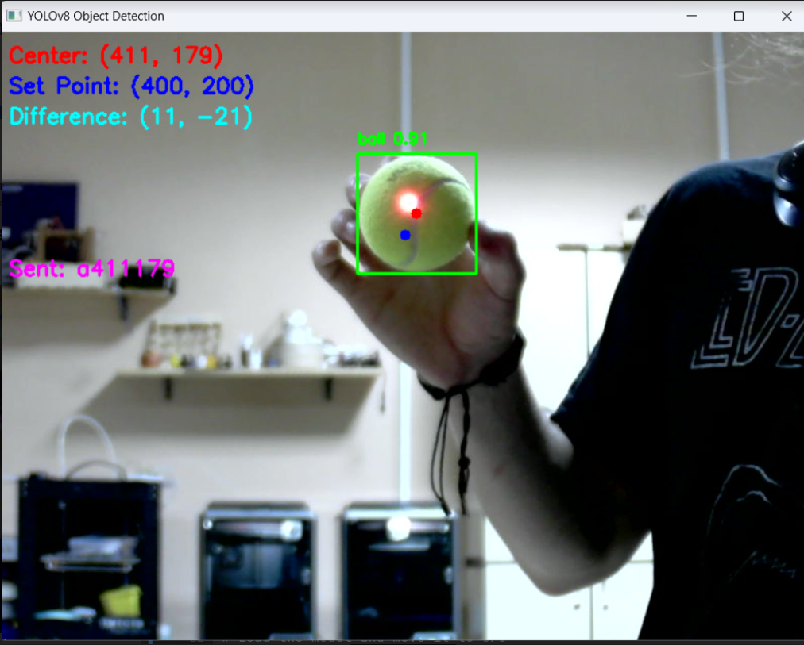  
*Picture #11 – Screenshot: Machine learning model detecting tennis ball*

## 6.3. Result & Comments

The resulting aiming system from this project operates with a slight delay, which can be attributed to both hardware limitations of the camera and the laptop running the object detection algorithm, as well as non-optimal code implementation. However, this delay could have been mitigated by utilizing a better-trained machine learning model, leaving room for improvement.

Regarding the motor control, while the current PID coefficient configuration works well enough for demonstration purposes, further tuning could potentially enhance the overall performance.

A significant limitation arises from the combination of a poorly trained machine learning model and a low frame rate camera. This setup struggles to recognize rapidly moving objects. When the system loses sight of the target, it defaults to the center of the frame for the projected point. This behavior results in abrupt jumps in the projected point, effectively introducing high-frequency noise.

This noise poses a challenge for the derivative (D) term in a PID controller. Without a robust low-pass filter—which would introduce its own delay—the D term becomes nearly unusable. To address this, I opted to implement a simple PI controller instead, effectively setting the D coefficient to zero or a value very close to it. This adjustment proved adequate for maintaining acceptable system performance.

The project has largely achieved its initial goal of creating a real-time tracking system, albeit with a minor delay. The current performance closely approximates the original objective, and there's significant potential for improvement. Through further fine-tuning, code optimization, and modest hardware upgrades, the system could likely meet or exceed the initial performance targets.

The primary constraint is hardware limitations, particularly given the computational demands of computer vision tasks. These operations require a substantial number of calculations per second, making hardware capabilities a critical factor in system performance.

It's important to note that this project showcases the challenges and limitations that can arise when working with real-world hardware and software integration, particularly in the realm of computer vision and robotics. Despite not achieving real-time performance, the project demonstrates the ability to implement object detection, data transmission, and motor control effectively, providing a solid foundation for further improvements and refinements.

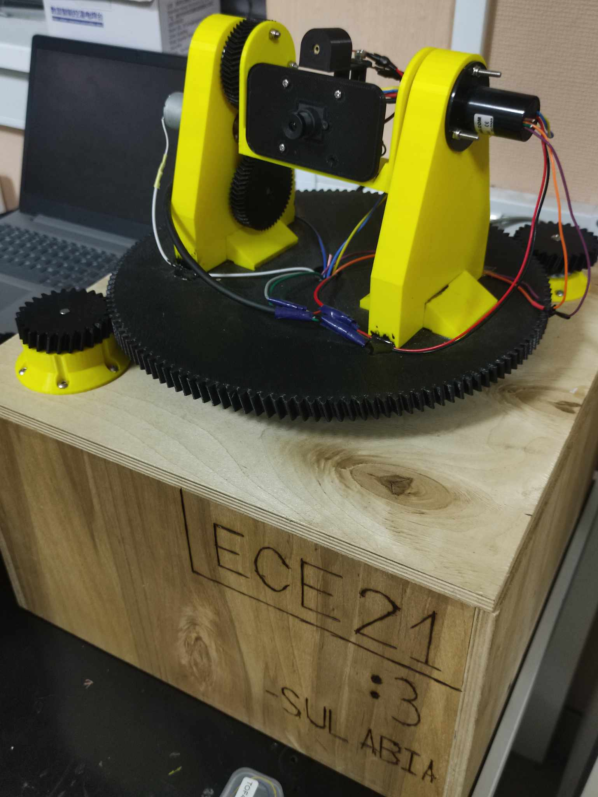

*Picture #12 – Final Look*

# 7. Conclusion

The target tracking system developed in this project successfully demonstrates the integration of computer vision techniques and mechanical positioning mechanisms to achieve real-time object tracking and aiming. The system utilizes a custom-built mechanical assembly featuring a Pan-Tilt device driven by DC motors and controlled by an STM32 microcontroller. The computer vision component leverages the YOLOv8n object detection model fine-tuned on a dataset of tennis balls, enabling robust detection and tracking of the target object.

The project's results showcase the system's ability to detect and maintain focus on a target object, albeit with a slight delay caused by hardware limitations and non-optimal code implementation. The use of a moving average filter introduces additional latency but improves the stability of the transmitted data. While the system falls slightly short of achieving true real-time performance, the project highlights the potential for further improvements through hardware upgrades, code optimization, and better model training.

Throughout the development process, several interesting challenges were encountered and overcome. Preserving the signal integrity of the USB camera cable while modifying it extensively by feeding it through slip rings and cutting and recombining it was a significant hurdle. Ensuring synchronized and correct data transfer over the serial connection required careful implementation. Diving deep into digital PID systems, understanding tuning approaches, implementation details, and addressing issues like integrator windup and derivative kick expanded the knowledge gained.

Additionally, learning to account for material expansion during 3D printing and designing mechanical parts that fit together precisely was a valuable experience. Mastering efficient data reception techniques on the STM32 and refining C programming skills were essential aspects of the project. Furthermore, understanding deep learning algorithms, preventing overfitting, leveraging online resources for data science tasks requiring high computing power, and getting a grasp of object detection techniques in deep learning were crucial components of the project's success.

Future plans for this project may involve exploring more advanced object detection and tracking algorithms, implementing more sophisticated control strategies, and optimizing the system's performance for specific use cases. Additionally, the integration of alternative end effectors, such as robotic arms or specialized tools, could expand the system's capabilities and potential applications.

Overall, this project serves as a compelling demonstration of the synergy between computer vision, robotics, and mechanical engineering, offering a solid foundation for further research and development in the field of autonomous target tracking systems.

# 8. List of References & Resources Used

<https://www.youtube.com/watch?v=ZhDO16FDmxA><https://www.youtube.com/watch?v=uNZmLPZHon8&t=23s><https://www.youtube.com/watch?v=zOByx3Izf5U><https://www.youtube.com/playlist?list=PLrOFa8sDv6jcp8E3ayUFZ4iNI8uuPjXHe><https://www.youtube.com/playlist?list=PLS1QulWo1RIa7D1O6skqDQ-JZ1GGHKK-K><https://www.youtube.com/playlist?list=PLNyfXcjhOAwO5HNTKpZPsqBhelLF2rWQx><https://deepbluembedded.com/stm32-arm-programming-tutorials/><https://github.com/Majid-Derhambakhsh/PID-Library><https://eprints.gla.ac.uk/3815/1/IEEE_CS_PID_01580152.pdf><https://www.sciencedirect.com/science/article/pii/S1474667015386900><https://universe.roboflow.com/><https://colab.research.google.com/>

# 9. მადლობის გვერდი

მინდა მადლობა გადავუხადო შემდეგ ადამიანებს:

* **ზვიად სულაბერიძეს** - რიგ საკითხებში დახმარების გაწევისთვის.
* **ირაკლი შელიას** - პრეზენტაციაზე გამოყენებული ლეპტოპის თხოვებისთვის, რომლემაც დიდ წილად განაპირობა ის, რომ პროექტი მუშაობს.
* **ნიკა მიქაბერიძეს და ლუკა დარსალიას** - მანქანურ სწავლებასთან დაკავშირებულ საკითხებში დახმარებისთვის.
* **ირაკლი დონგუზაშვილს** - ლაბორატორიაში არსებული ინვენტარის 90%-ის წყაროობისთვის.
* **ვაჟა ფურცელაძეს** - რიგ საკითხებში დახმარების გაწევისთვის.
* **გუგა ვარდიაშვილს** - ჩვენი კურსის გვერდში დგომისთვის.
* **მთლიან ECE21-ს** - იმისთვის, რომ საუკეთესოები არიან.
* **ავთო მღებრიშვილს** - პროექტის დასაწყისში მისი პრინტერის თხოვნისთვის.

# Appendix

<https://github.com/AlwaysAbia/ECE21_Junior_Project>